Name: Mudit Mohit Assignment 4: Bubble Sorting

Enrolment Number: BT21GCS057

Section: B2

Q1.) Write a program to sort an array of integers using the Bubble Sort algorithm. At last, analyze your program over the following operations:

1. List is in sorted order
2. List is in unsorted order
3. What is the best-case and worst-case complexity of your program?

Ans.

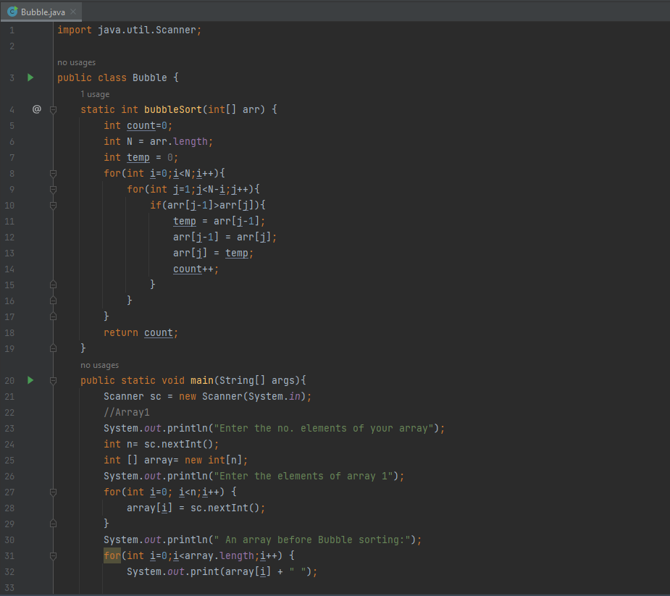

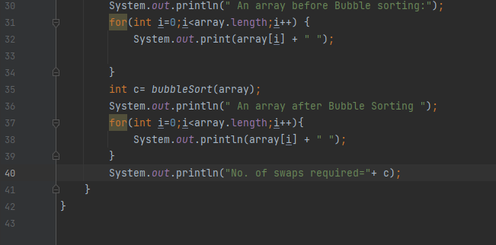

Output:

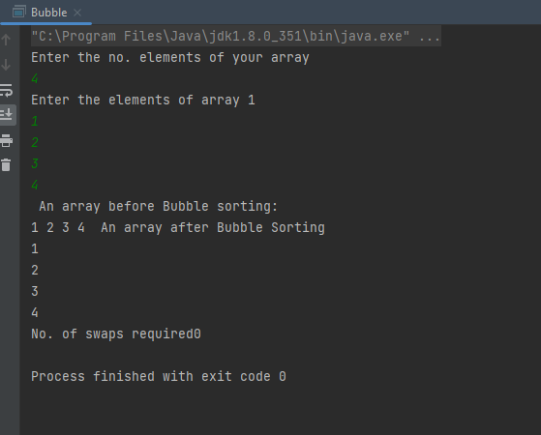

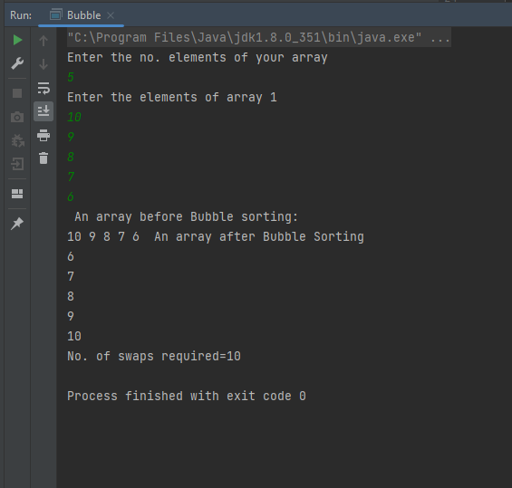

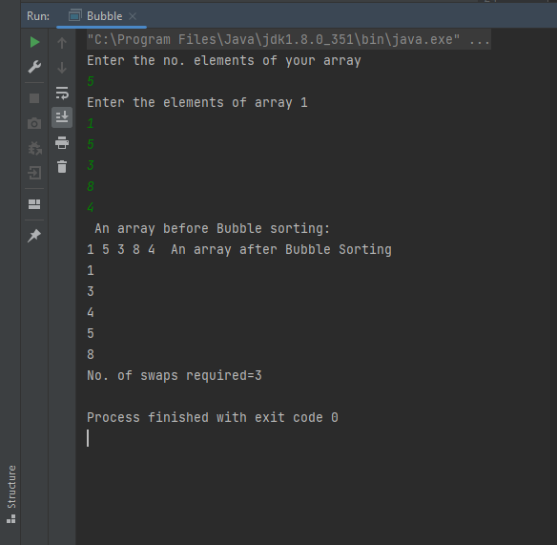

Time complexity:

For the average and worst case, time complexity =O(n^2)

For best case= O(n)